Six Core Elements of Health Care Transition 2.0
Transitioning Youth
to an Adult Health Care Provider
for use by Pediatric, Family Medicine, and Med-Peds Providers

Table of Contents
Preamble | 1
Six Core Elements of Health Care Transition 2.0: Side-by-Side Version | 2
Six Core Elements of Health Care Transition 2.0: Transitioning Youth to an Adult Health Care Provider | 4
Introduction to Each of the Six Core Elements | 5
Core Element Samples
- Transition Policy
- Sample Transition Policy | 7
- Transition Tracking and Monitoring
- Sample Individual Transition Flow Sheet | 8
- Sample Transition Registry | 9
- Transition Readiness
- Sample Transition Readiness Assessment for Youth | 10
- Sample Transition Readiness Assessment for Parents/Caregivers | 11
- Transition Planning
- Sample Plan of Care | 12
- Sample Medical Summary and Emergency Care Plan | 13
- Sample Condition Fact Sheet | 16
- Transfer of Care
- Sample Transfer of Care Checklist | 18
- Sample Transfer Letter | 19
- Transfer Completion
- Sample Health Care Transition Feedback Survey for Youth | 20
- Sample Health Care Transition Feedback Survey for Parents/Caregivers | 22
Measurement Approaches
- Current Assessment of Health Care Transition Activities | 24
- Health Care Transition Process Measurement Tool | 27

Got Transition is pleased to share this updated package of the Six Core Elements of Health Care Transition for use by pediatric, family medicine, and med-peds providers to benefit all youth, including those with special needs, as they transition from pediatric to adult-centered health care. Consistent with the AAP/AAFP/ACP Clinical Report on Health Care Transition, transition consists of joint planning with youth and parents/caregivers to foster development of self-care skills and active participation in decision-making. It also consists of assistance in identifying adult providers and ensuring a smooth transfer to adult-centered care with current medical information.
Recognizing and responding to the diversity among youth, young adults and their families is essential to the transition process. This diversity may include but is not limited to differences in culture, race, ethnicity, languages spoken, intellectual abilities, gender, sexual orientation, and age. Since implementation of the Six Core Elements depends so much on patient and provider communication, health plans and practices should use appropriate oral and written communications, including interpretation and translation services and health literacy supports as needed. In addition, engaging youth and parents/caregivers from various cultural backgrounds in the development and evaluation of a transition quality improvement process is important.
The Six Core Elements of Health Care Transition 2.0 define the basic components of health care transition support and the linked sample tools in this package provide tested means for transitioning youth to adult health care providers. Corresponding packages are available for 1) transitioning to an adult approach to care without changing providers and 2) integrating young adults into adult health care. Originally developed in 2009, this updated version incorporates the results of recent transition learning collaborative experiences in several states, an examination of transition innovations in the United States and abroad, and reviews by over 50 pediatric and adult health care professionals and youth and family experts.
To implement the Six Core Elements, a quality improvement approach is recommended. Plan-do-study-act (PDSA) cycles provide a useful way to incrementally adopt the Six Core Elements as a standard part of care for youth and their families. The process begins with the creation of a collaborative pediatric and adult team that could include physicians, nurse practitioners, physician assistants, nurses, social workers, care coordinators, medical assistants, administrative staff, IT staff, and youth/young adults and families. Leadership support from the practice, plan, or academic department is critical as well. Oftentimes, practices decide to begin with a subset of youth in order to pilot the pediatric and adult delivery system changes needed for transition. Sample tools that can be customized for use in primary and specialty care are available in this package and on www.GotTransition.org.
Got Transition has developed two different measurement approaches, described below, to assess the extent to which the Six Core Elements of Health Care Transition 2.0 are being incorporated into clinical processes. Both are aligned with the AAP/AAFP/ACP’s Clinical Report on Transition and the Six Core Elements.
- Current Assessment of Health Care Transition Activities. This is a qualitative self-assessment method that allows individual providers, practices, or networks to determine the level of health care transition support currently available to youth and families transitioning from pediatric to adult health care. It is intended to provide a current snapshot of how far along a practice is in implementing the Six Core Elements.
- Health Care Transition Process Measurement Tool. This is an objective scoring method, with documentation specifications, that allows a practice or network to assess progress in implementing the Six Core Elements and, eventually, dissemination to all youth ages 12 and over. It is intended to be conducted at the start of a transition improvement initiative – as a baseline measure and then repeated periodically to assess progress.
Got Transition welcomes your comments and feedback on the updated Six Core Elements of Health Care Transition 2.0. Please them to info@GotTransition.org. Thank you for your interest in the successful health care transitions of youth and young adults from pediatric to adult-centered care.

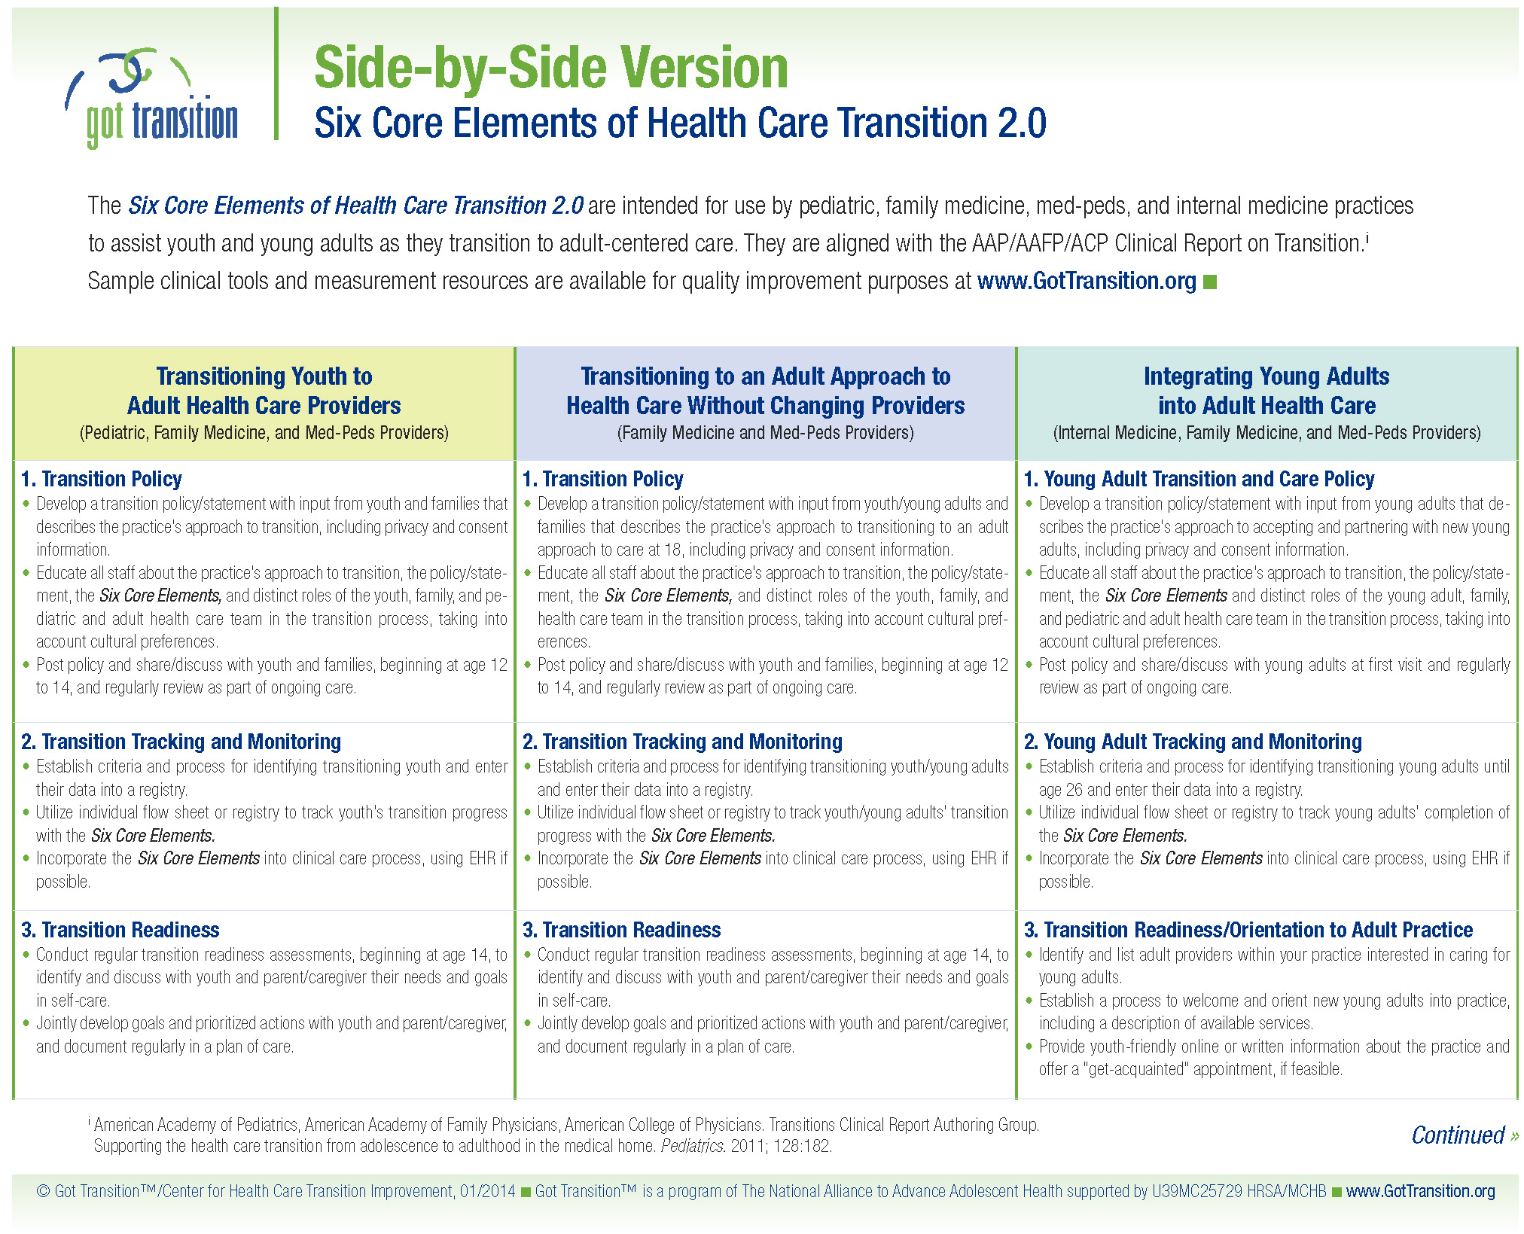

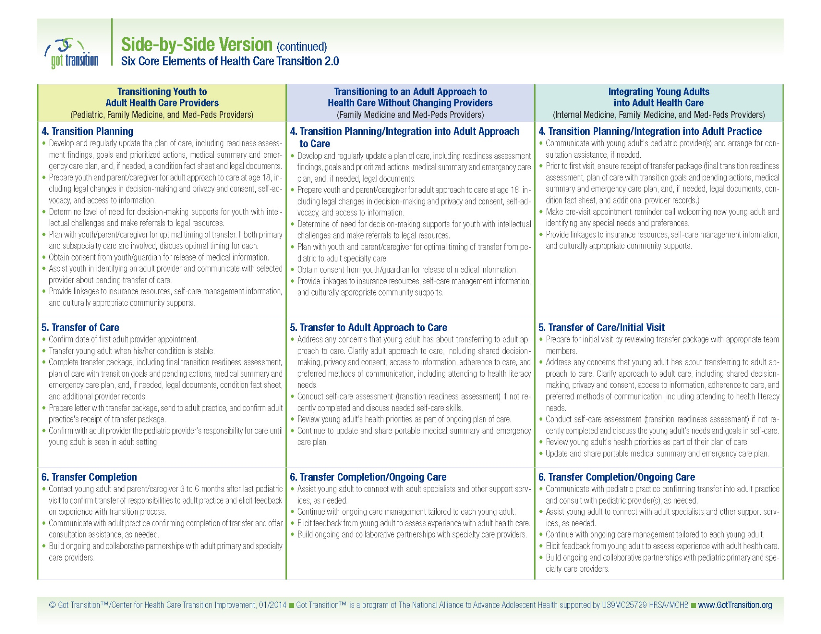

1. Transition Policy
- Develop a transition policy/statement with input from youth and families that describes the practice’s approach to transition, including privacy and consent information.
- Educate all staff about the practice’s approach to transition, the policy/statement, the Six Core Elements, and distinct roles of the youth, family, and pediatric and adult health care team in the transition process, taking into account cultural preferences.
- Post policy and share/discuss with youth and families, beginning at age 12 to 14, and regularly review as part of ongoing care.
2. Transition Tracking and Monitoring
- Establish criteria and process for identifying transitioning youth and enter their data into a registry.
- Utilize individual flow sheet or registry to track youth’s transition progress with the Six Core Elements.
- Incorporate Six Core Elements into clinical care process, using EHR if possible.
3. Transition Readiness
- Conduct regular transition readiness assessments, beginning at age 14, to identify and discuss with youth and parent/caregiver their needs and goals in self-care.
- Jointly develop goals and prioritized actions with youth and parent/caregiver and document regularly in a plan of care.
4. Transition Planning
- Develop and regularly update the plan of care, including readiness assessment findings, goals and prioritized actions, medical summary and emergency care plan, and, if needed, a condition fact sheet and legal documents.
- Prepare youth and parent/caregiver for adult approach to care at age 18, including legal changes in decision-making and privacy and consent, self-advocacy, and access to information.
- Determine need for decision-making supports for youth with intellectual challenges and make referrals to legal resources.
- Plan with youth and parent/caregiver for optimal timing of transfer. If both primary and subspecialty care are involved, discuss optimal timing for each.
- Obtain consent from youth/guardian for release of medical information.
- Assist youth in identifying an adult provider and communicate with selected provider about pending transfer of care.
- Provide linkages to insurance resources, self-care management information, and culturally appropriate community supports.
5. Transfer of Care
- Confirm date of first adult provider appointment.
- Transfer young adult when his/her condition is stable.
- Complete transfer package, including final transition readiness assessment, plan of care with transition goals and pending actions, medical summary and emergency care plan, and, if needed, legal documents, condition fact sheet, and additional provider records.
- Prepare letter with transfer package, send to adult practice, and confirm adult practice’s receipt of transfer package.
- Confirm with adult provider the pediatric provider’s responsibility for care until young adult is seen in adult setting.
6. Transfer Completion
- Contact young adult and parent/caregiver 3 to 6 months after last pediatric visit to confirm transfer of responsibilities to adult practice and elicit feedback on experience with transition process.
- Communicate with adult practice confirming completion of transfer and offer consultation assistance, as needed.
- Build ongoing and collaborative partnerships with adult primary and specialty care providers.

- Transition Policy
Creating a written practice policy on transition is the first element in these health care transition quality recommendations. Developed by your practice or health system, with input from youth and families, the policy provides consensus among the practice staff, mutual understanding of the process involved, and a structure for evaluation. The policy should include a transition time frame (When are youth expected to leave your practice?) and an explanation of the practice’s transition approach (What will your practice offer youth and families to assist them in transition?). It should also explain the legal changes that take place in privacy and consent at age 18, even if the youth has not left your practice. The policy should be shared with youth and families beginning at ages 12 to 14 and publicly posted.
- Transition Tracking and Monitoring
Establishing a mechanism to track progress of each youth as they receive the Six Core Elements is the second element in these health care transition quality recommendations. An individual flow sheet within the chart can be used to track individual patient progress with the Six Core Elements. Information from an individual flow sheet can be used to populate a registry and help to monitor the transition progress within a larger population. Practices may elect to start monitoring transition progress with a subset of youth with chronic conditions. The long-term goal is to track health care transition progress among all youth ages 12 and older, with and without chronic conditions.
- Transition Readiness
Assessing youth’s transition readiness and self-care skills is the third element in these health care transition quality recommendations. Use of a standardized transition assessment tool is helpful in engaging youth and families in setting health priorities, addressing self-care needs to prepare them for an adult approach to care at age 18, and navigating the adult health care system, including health insurance. Providers can use the results to jointly develop a plan of care with youth and families. Transition readiness assessment should begin at age 14 and continue through adolescence and young adulthood, as needed.
- Transition Planning
Planning for transition as a collaborative and continuous process with youth and families is the fourth element in these health care transition recommendations. It encompasses several activities. To begin with, it is important to develop and regularly update a plan of care that identifies the transitioning youth’s priorities and addresses how learning about health and health care can support their priorities. In addition, to further youth’s independence, developing and sharing a medical summary and emergency care plan, and establishing linkages to community-based supports is also important. Starting at about age 16, providers should assist youth and families in preparing for changes in decision-making when youth legally become adults at age 18. For some youth and families this may require referring them to legal resources about supported decision-making, and for others it may require obtaining their consent to involve parents/caregivers. Finally, transition planning involves inquiring about youth’s preferences for transferring to an adult provider and assisting them in this process. An up-to-date and vetted list of adult primary and specialty care providers interested in care for young adults should be shared with youth and families.
- Transfer of Care
Creating a transfer of care checklist for the practice, preparing a transfer package for youth leaving the practice, and communicating with the new adult provider is the fifth element in these health care transition quality recommendations. The transfer package contains a transfer letter along with the final transition readiness assessment, transition goals and actions accomplished or yet to be achieved, a medical summary and emergency care plan, and, if needed, legal documents. If the youth’s condition is one that adult providers do not routinely encounter, adding a condition fact sheet to the transfer package is helpful. A telephone conversation with the adult provider may be warranted for transitioning youth with more complex health and psychosocial needs. Transfer to an adult provider is recommended before the age of 22.
- Transfer Completion
Confirming transfer completion, arranging for pediatric consultation (as needed), and assessing youth and family experience with transition support are all part of the sixth element in these health care transition quality recommendations. Communicating with the adult provider about the pediatric provider’s residual responsibility for care until the first visit is completed and the young adult selects the adult provider as his/her primary care medical home is necessary. Until the young adult has made and kept an appointment establishing care in the new medical home, the pediatric provider should expect to have some residual responsibility for care. Examples may include medication refills or acute care visits. In addition, communicating with the adult practice about available pediatric consultation assistance is also important. To evaluate the success of the transition process, having a mechanism to obtain and incorporate the feedback from youth and families will improve the practice’s approach to transition. Such a survey can be done three to six months after transfer.

[Pediatric Practice Name] is committed to helping our patients make a smooth transition from pediatric to adult health care. This process involves working with youth, beginning at ages 12 to 14, and their families to prepare for the change from a “pediatric” model of care where parents make most decisions to an “adult” model of care where youth take full responsibility for decision-making. This means that we will spend time during the visit with the teen without the parent present in order to assist them in setting health priorities and supporting them in becoming more independent with their own health care.
At age 18, youth legally become adults. We respect that many of our young adult patients choose to continue to involve their families in health care decisions. Only with the young adult’s consent will we be able to discuss any personal health information with family members. If the youth has a condition that prevents him/her from making health care decisions, we encourage parents/caregivers to consider options for supported decision-making.
We will collaborate with youth and families regarding the age for transferring to an adult provider and recommend that this transfer occur before age 22. We will assist with this transfer process, including helping to identify an adult provider, sending medical records, and communicating with the adult provider about the unique needs of our patients.
As always, if you have any questions or concerns, please feel free to contact us.

Patient Name: ______________ Date of Birth: ___________

Primary Diagnosis: ______________ Transition Complexity: ______________
Low, moderate, or high
Transition Policy
-Practice policy on transition discussed/shared with youth and parent caregiver _________
Date
Transition Readiness Assessment
-Conducted transition readiness assessment _________ _________ _________
Date Date Date
-Included transition goals and prioritized actions in plan of care _________ _________ _________
Date Date Date
Medical Summary and Emergency Plan
-Updated and Shared medical summary and emergency plan _________ _________ _________
Date Date Date
Adult Model of Care
-Decision-making changes, privacy, and consent in adult care discussed with youth and parent/caregiver (if needed, discussed plans for supported decision-making) _________
Date
-Timing of transfer discussed with youth and parent/caregiver _________
Date
-Selected Adult Provider
______________ ______________ ______________ ______________ ______________
Name Clinic Phone Fax First Appointment Completed
Transfer of Care
-Prepared transfer package including:
- Transfer letter, including effective of date of transfer of care to adult provider
- Final transition readiness assessment
- Plan of care, including goals and actions
- Updated medical summary and emergency care plan
- Legal documents, if needed
- Condition fact sheet, if needed
- Additional provider records, if needed
-Sent transfer package _________
Date
-Communicated with adult provider about transfer _________
Date
-Elicited feedback from young adult after transfer from pediatric care _________
Date

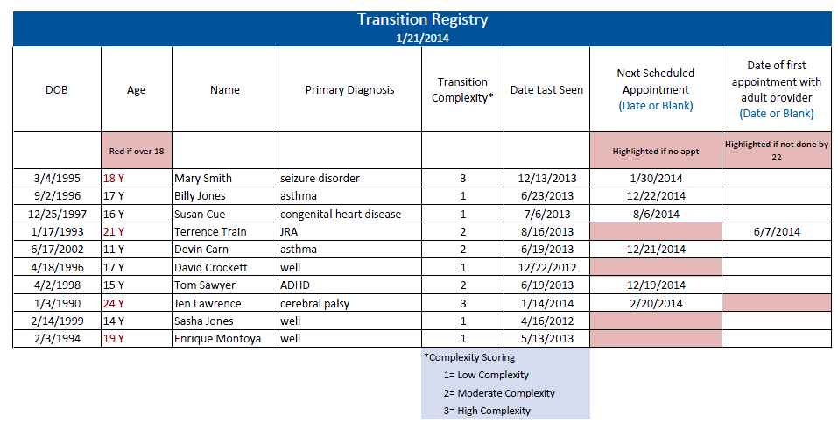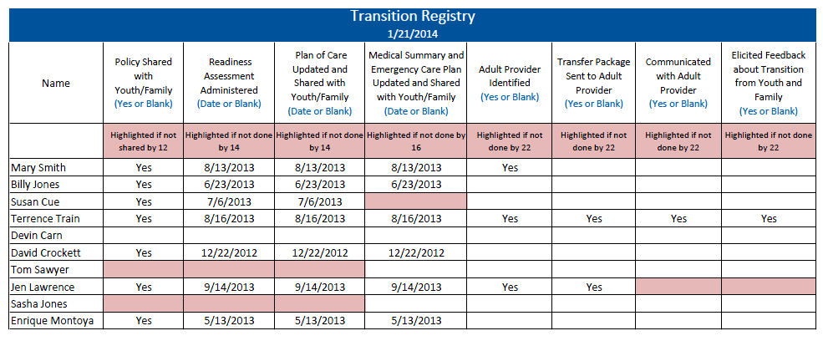

Please fill out this form to help us see what you already know about your health and how to use health care and the areas that you need to learn more about. If you need help completing this form, please ask your parent/caregiver.
Date:
Name: Date of Birth:

Transition Importance and Confidence On a scale of 0 to 10, please circle the number that best describes how you feel right now.

How important is it to you to prepare for/change to an adult doctor before age 22?
0 (not) | 1 | 2 | 3 | 4 | 5 | 6 | 7 | 8 | 9 | 10 (very)
How confident do you feel about your ability to prepare for/change to an adult doctor?
0 (not) | 1 | 2 | 3 | 4 | 5 | 6 | 7 | 8 | 9 | 10 (very)

My Health Please check the box that applies to you right now. | Yes, I know this | I need to learn | Someone needs to do this… Who?
I know my medical needs. | ☐ | ☐ | ☐
I can explain my medical needs to others. | ☐ | ☐ | ☐
I know my symptoms including ones that I quickly need to see a doctor for. | ☐ | ☐ | ☐
I know what to do in case I have a medical emergency. | ☐ | ☐ | ☐
I know my own medicines, what they are for, and when I need to take them. | ☐ | ☐ | ☐
I know my allergies to medicines and medicines I should not take. | ☐ | ☐ | ☐
I carry important health information with me every day (e.g. insurance card, allergies, medications, emergency contact information, and medical summary). | ☐ | ☐ | ☐
I understand how health care privacy changes at age 18 when legally an adult. | ☐ | ☐ | ☐
I can explain to others how my customs and beliefs affect my health care decisions and medical treatment. | ☐ | ☐ | ☐
Using Health Care
I know or I can find my doctor’s phone number. | ☐ | ☐ | ☐
I make my own doctor appointments. | ☐ | ☐ | ☐
Before a visit, I think about questions to ask. | ☐ | ☐ | ☐
I have a way to get to my doctor’s office. | ☐ | ☐ | ☐
I know to show up 15 minutes before the visit to check in. | ☐ | ☐ | ☐
I know where to go to get medical care when the doctor’s office is closed. | ☐ | ☐ | ☐
I have a file at home for my medical information. | ☐ | ☐ | ☐
I have a copy of my current plan of care. | ☐ | ☐ | ☐
I know how to fill out medical forms. | ☐ | ☐ | ☐
I know how to get referrals to other providers. | ☐ | ☐ | ☐
I know where my pharmacy is and how to refill my medicines. | ☐ | ☐ | ☐
I know where to get blood work or x-rays if my doctor orders them. | ☐ | ☐ | ☐
I have a plan so I can keep my health insurance after 18 or older. | ☐ | ☐ | ☐
My family and I have discussed my ability to make my own health care decisions at age 18. | ☐ | ☐ | ☐

Please fill out this form to help us see what your child already knows about his or her health and the areas that you think he/she needs to learn more about. After you complete the form, compare your answers with the form your child has complete. Your answers may be different. We will help you work on some steps to increase your child’s health care skills.
Date:
Name: Date of Birth:
Transition Importance and Confidence On a scale of 0 to 10; please circle the number that best describes how you feel right now.

How important is it for your child to prepare for/change to an adult doctor before age 22?
0 (not) | 1 | 2 | 3 | 4 | 5 | 6 | 7 | 8 | 9 | 10 (very)
How confident do you feel about your child’s ability to prepare for/change to an adult doctor?
0 (not) | 1 | 2 | 3 | 4 | 5 | 6 | 7 | 8 | 9 | 10 (very)

My Health Please check the box that applies to your child right now. | Yes, he/she knows this | He/she needs to learn | Someone needs to do this… Who?
My child knows his/her medical needs. | ☐ | ☐ | ☐
My child can explain his/her medical needs to others. | ☐ | ☐ | ☐
My child knows his/her symptoms including ones that he/she quickly needs to see a doctor for. | ☐ | ☐ | ☐
My child knows what to do in case he/she has a medical emergency. | ☐ | ☐ | ☐
My child knows his/her own medicines, what they are for, and when he/she needs to take them. | ☐ | ☐ | ☐
My child knows his/her allergies to medicines and medicines he/she should not take. | ☐ | ☐ | ☐
My child carries important health information with him/her every day (e.g. insurance card, allergies, medications, emergency contact information, and medical summary). | ☐ | ☐ | ☐
My child knows he/she can see a doctor alone as I wait in the waiting room. | ☐ | ☐ | ☐
My child understands how health care privacy changes at age 18. | ☐ | ☐ | ☐
My child can explain to others how his/her customs and beliefs affect health care decisions and medical treatment. | ☐ | ☐ | ☐
Using Health Care
My child knows or can find his/her doctor’s phone number. | ☐ | ☐ | ☐
My child makes his/her own doctor appointments. | ☐ | ☐ | ☐
Before a visit, my child thinks about questions to ask. | ☐ | ☐ | ☐
My child has a way to get to his/her doctor’s office. | ☐ | ☐ | ☐
My child knows to show up 15 minutes before the visit to check in. | ☐ | ☐ | ☐
My child knows where to go to get medical care when the doctor’s office is closed. | ☐ | ☐ | ☐
My child has a file at home for his/her medical information. | ☐ | ☐ | ☐
My child has a copy of his/her current plan of care. | ☐ | ☐ | ☐
My child knows how to fill out medical forms. | ☐ | ☐ | ☐
My child knows how to get referrals to other providers. | ☐ | ☐ | ☐
My child knows where his/her pharmacy is and how to refill his/her medicines. | ☐ | ☐ | ☐
My child knows where to get blood work or x-rays if his/her doctor orders them. | ☐ | ☐ | ☐
My child has a plan to keep his/her health insurance after ages 18 or older. | ☐ | ☐ | ☐
My child and I have discussed his/her ability to make his/her own health care decisions at age 18. | ☐ | ☐ | ☐
My child and I have discussed a plan for supported decision-making, if needed. | ☐ | ☐ | ☐

Instructions: This sample plan of care is a written document developed jointly with the transitioning youth to establish priorities and a course of action that integrates health and personal goals. Motivational interviewing and strength-based counseling are key approaches in developing a collaborative process and shared decision-making. Information from the transition readiness assessment can be used to guide the development of health goals. The plan of care should be dynamic and updated regularly and sent to the new adult provider as part of the transfer package along with the latest transition readiness assessment, medical summary and emergency care plan, and, if needed, a condition fact sheet and legal documents.
Name: |  |  |  |  | Date of Birth:
Primary Diagnosis: |  |  |  |  | Secondary Diagnosis:
What matters most to you as you become an adult? How can learning more about your health condition and how to use health care support your goals?

Prioritized Goals |  | Issues or Concerns |  |  |  | Actions |  | Person Responsible |  | Target Date | Date  Complete
Initial Date of Plan: | ________________ |  | Last Updated: | _____________________ |  |  | Parent/Caregiver Signature: |  | ___________________
Clinician Signature: | ________________ |  | Care Staff Contact: | ____________________ |  |  | Care Staff Phone: |  | ___________________

This document should be shared with and carried by youth and families/caregivers.
Date Completed: |  |  |  |  |  |  |  |  |  |  |  |  |  | Date Revised:
Form completed by:
Contact Information
Name: |  |  |  |  |  |  |  |  |  |  |  |  |  | Nickname:
DOB: |  |  |  |  |  |  |  |  |  |  |  |  |  | Preferred Language:
Parent (Caregiver): |  |  |  |  |  |  |  |  |  |  |  |  |  | Relationship:
Address:
Cell #: Home #: |  |  |  |  |  |  |  |  |  |  |  |  |  |  | Best Time to Reach:
E-Mail: |  |  |  |  |  |  |  |  |  |  |  |  |  |  | Best Way to Reach: Text Phone Email
Health Insurance/Plan: |  |  |  |  |  |  |  |  |  |  |  |  |  |  | Group and ID #:
Emergency Care Plan
Emergency Contact: Relationship: Phone:
Preferred Emergency Care Location:
Common Emergent Presenting Problems |  |  |  |  |  |  |  | Suggested Tests |  |  |  |  |  |  |  | Treatment Considerations
Special Concerns for Disaster:
Allergies and Procedures to be Avoided
Allergies |  |  |  |  |  |  |  | Reactions
To be avoided |  |  |  |  |  |  |  | Why?
Medical Procedures:
Medications:
Diagnoses and Current Problems
Problem |  |  |  |  |  |  |  | Details and Recommendations
Primary Diagnosis
Secondary Diagnosis
Behavioral
Communication
Feed & Swallowing
Hearing/Vision
Learning
Orthopedic/Musculoskeletal
Physical Anomalies
Respiratory
Sensory
Stamina/Fatigue
Other

Medications
Medications |  | Dose |  | Frequency |  |  |  |  |  | Medications |  |  |  |  |  |  |  | Dose |  | Frequency
Health Care Providers
Provider |  |  | Primary and Specialty |  |  |  |  |  | Clinic or Hospital |  |  |  |  |  |  |  |  |  | Phone |  | Fax
Prior Surgeries, Procedures, and Hospitalizations
Date
Date
Date
Date
Date
Baseline
Baseline Vital Signs: Ht Wt RR HR BP
Baseline Neurological Status:
Most Recent Labs and Radiology
Test |  |  |  |  |  | Date |  |  |  |  |  |  | Result
EEG
EKG
X-Ray
C-Spine
MRI/CT
Other

Other

Equipment, Appliances, and Assistive Technology
Gastrostomy |  |  |  |  | Adaptive Seating |  |  |  |  |  |  |  |  |  |  |  | Wheelchair
Tracheostomy |  |  |  |  | Communication Device |  |  |  |  |  |  |  |  |  |  |  | Orthotics
Suctions |  |  |  |  | Monitors: |  |  |  |  |  |  |  |  |  |  |  | Crutches
Nebulizer |  |  |  |  | Apnea |  |  |  |  |  |  | O2 |  |  |  |  | Walker
 |  |  |  |  | Cardiac |  |  |  |  |  |  | Glucose
Other

School and Community Information
Agency/School |  |  |  |  |  |  | Contact Information
 |  |  |  |  |  |  | Contact Person: Phone:
 |  |  |  |  |  |  | Contact Person: Phone:
 |  |  |  |  |  |  | Contact Person: Phone:
Special information that the youth or family wants health care professionals to know

_________________________________________________________________________________
Youth Signature Print Name Phone Number Date

_________________________________________________________________________________
Parent/Caregiver Print Name Phone Number Date
__________________________________________________________________________________
Primary Care Provider Signature Print Name Phone Number Date
__________________________________________________________________________________
Care Coordinator Signature Print Name Phone Number Date
Please attach the immunization record to this form.

Reprinted with permission from the Spina Bifida Association
Reprinted with permission from the Spina Bifida Association

Patient Name: ______________ Date of Birth: ___________

Primary Diagnosis: ______________ Transition Complexity: ______________
Low, moderate, or high
-Prepared transfer package including:
- Transfer letter, including effective of date of transfer of care to adult provider
- Final transition readiness assessment
- Plan of care, including transition goals and pending actions
- Updated medical summary and emergency care plan
- Guardianship or health proxy documents, if needed
- Condition fact sheet, if needed
- Additional provider records, if needed
-Sent transfer package _________
Date
-Communicated with adult provider about transfer _________
Date

Dear Adult Provider,
Name is an age year-old patient of our pediatric practice who will be transferring to your care on date of this year. His or her primary chronic condition is condition, and his or her secondary conditions are conditions. Name’s related medications and specialists are outlined in the enclosed transfer package that includes his or her medical summary and emergency care plan, plan of care, and transition readiness assessment. Name acts as his or her own guardian, and is insured under insurance plan until age age.
I have had name as a patient since age and am very familiar with his or her health condition, medical history, and specialists. I would be happy to provide any consultation assistance to you during the initial phases of name’s transition to adult health care. Please do not hesitate to contact me by phone or email if you have further questions.
Thank you very much for your willingness to assume the care of this young man or woman.

Sincerely,

This is a survey about your experience changing from pediatric to adult health care. You may choose to answer this survey or not. Your responses to this survey are confidential.
- How often did your previous health care provider explain things in a way that was easy to understand?
Always
Usually
Sometimes
Never

- How often did your previous health care provider listen carefully to you?
Always
Usually
Sometimes
Never

- Did your previous health care provider respect how your customs or beliefs affect your care?
A lot
Some
A little
Not at all

- Did your previous health care provider discuss with you or have an office policy that informed you at what age you may need to change to a new provider who treats mostly adults?
Yes
No

- Did you talk with your previous health care provider without your parent or guardian in the room?
Yes
No

- Did your previous health care provider actively work with you to gain skills to manage your own health and health care (e.g., know your medications and their side effects, know what to do in an emergency)?*
A lot
Some
A little
Not at all

- Did your previous health care provider actively work with you to think about and plan for the future (e.g., take time to discuss future plans about education, work, relationships, and development of independent living skills)?*
A lot
Some
A little
Not at all

- How often did you schedule your own appointments with your previous health care provider?
Never
Sometimes
Usually
Always

- Did your previous health care provider explain legal changes in privacy, decision-making, and consent that take place at age 18?
Yes
No

- Did your previous health care provider actively work with you to create a written plan to meet your health goals and needs?*
Yes
No

- Did your previous health care provider create and share with you your medical summary?
Yes
No

- Did your previous health care provider have information about community resources?
Yes
No

Continued »

- Do you know how you will be insured as you become an adult?*
Yes
No

- Did your previous health care provider assist you in identifying a new adult provider to transfer to?
Yes
No

- Did your adult health care provider have your medical records before your first visit?
Yes
No
Don’t Know
Have not had first visit yet

- Did you feel prepared to change to an adult health care provider?
Very prepared
Somewhat prepared
Not prepared

- At what age did you change to an adult health care provider?

Age ______

*Adapted from the National Survey of Children’s Health

- How could your pediatric health care provider have made your move to an adult health care provider better?
- How could your health care provider have made your move to an adult health care provider better?
___________________________________________________________________________________________________________________________________________________________________________________________________________________________________________________________________________________________________________________________________________________________________________________________________________________

Thank you.
This is an optional survey about your experience changing from pediatric to adult health care. If you choose to, please answer each question by marking the box to the left of the answer. Your responses to this survey are confidential.

- How often did your child’s health care provider explain things in a way that was easy to understand?
Always
Usually
Sometimes
Never

- How often did your child’s health care provider listen carefully to you?
Always
Usually
Sometimes
Never

- Did your child’s health care provider respect how your customs or beliefs affect your care?
A lot
Some
A little
Not at all

- Did your child’s health care provider discuss with you or have an office policy that informed you at what age your child may need to change to a new provider who treats mostly adults?
Yes
No

- Did your child talk with your health care provider alone while you waited in the waiting room?
Yes
No
Not applicable (if child has significant intellectual disabilities)

- Did your child’s health care provider actively work with your child to gain skills to manage his/her own health and health care (e.g., know his/her medications and their side effects, know what to do in an emergency)?*
A lot
Some
A little
Not at all

- Did your child’s health care provider actively work with your child to think about and plan for the future (e.g., take time to discuss future plans about education, work, relationships, and development of independent living skills)?*
A lot
Some
A little
Not at all

- How often did your child schedule his/her own appointments with his/her previous health care provider?
Never
Sometimes
Usually
Always
Not applicable

- Did your child’s health care provider explain legal changes in privacy, decision-making, and consent that take place at age 18?
Yes
No

- Did your child’s health care provider actively work with your child and you to create a written plan to meet his/her health goals and needs?*
Yes
No

- Did your child’s health care provider create and share his/her medical summary with your child and you?
Yes
No

- Did your child’s health care provider have information about community resources?
Yes
No

Continued »

- Do you know how your child will be insured as he/she becomes an adult?*
Yes
No

- Did your child’s health care provider assist in identifying a new adult provider to transfer to?
Yes
No

- Did your child’s adult health care provider have his/her medical records before the first visit?
Yes
No
Don’t Know
Have not had first visit yet

- Did your child feel prepared to change to an adult health care provider?
Very prepared
Somewhat prepared
Not prepared
Not applicable

- At what age did your child change to an adult health care provider?

Age ______

*Adapted from the National Survey of Children’s Health

- How could your child’s health care provider have made the move to an adult health care provider better for you and your child?
___________________________________________________________________________________________________________________________________________________________________________________________________________________________________________________________________________________________________________________________________________________________________________________________________________________

Thank you.
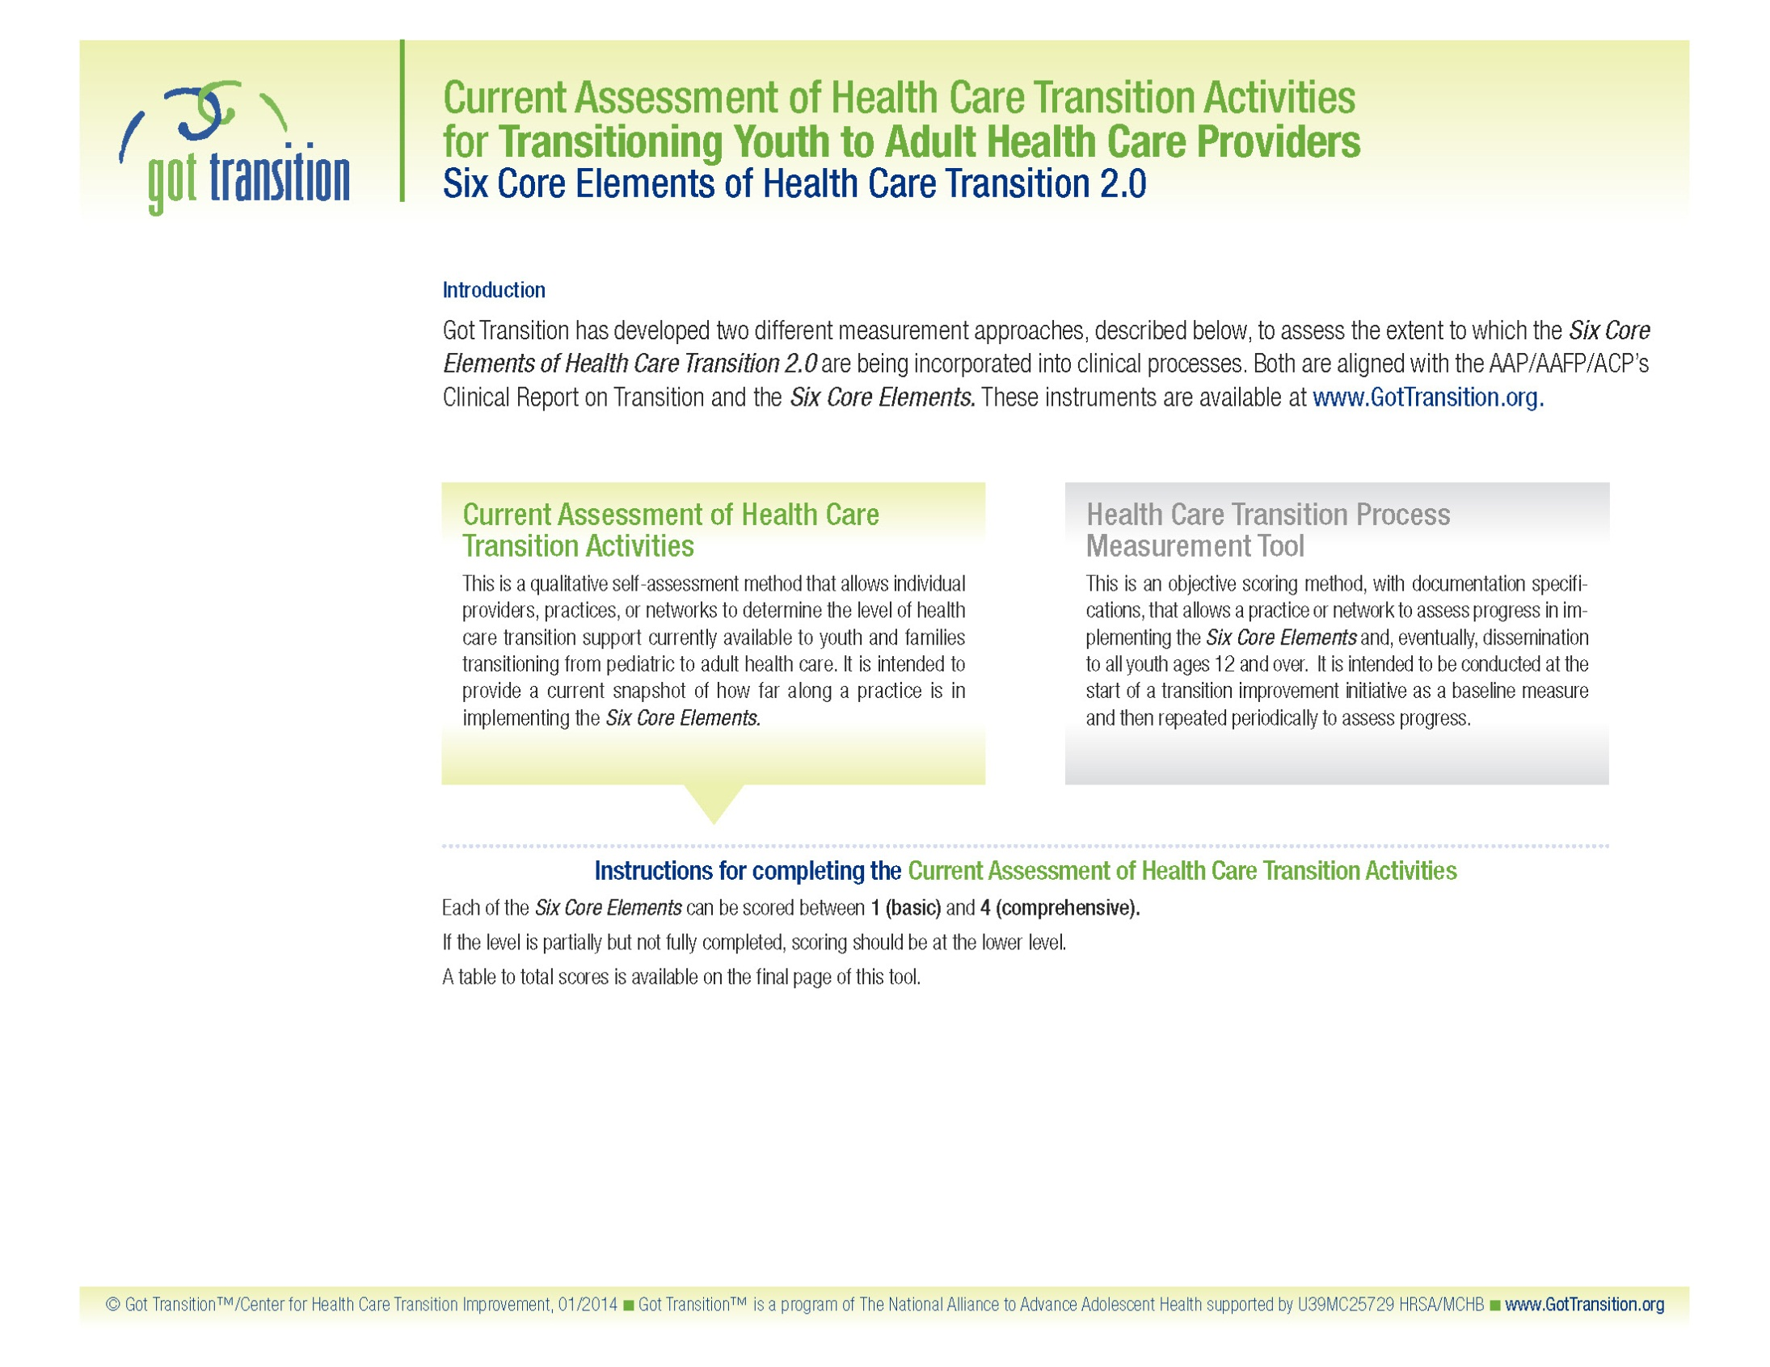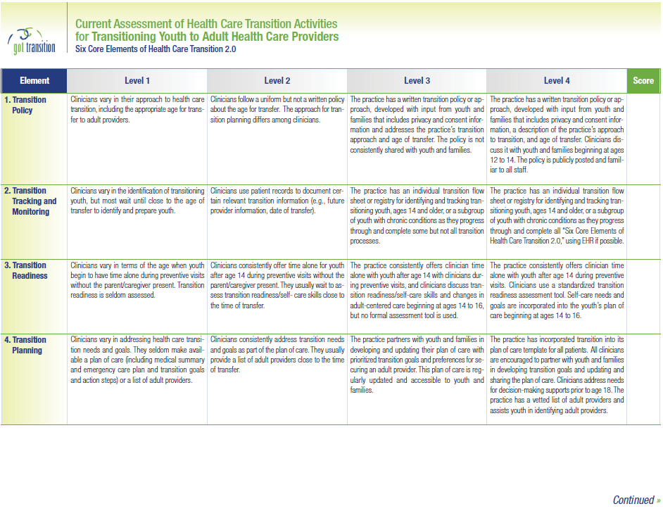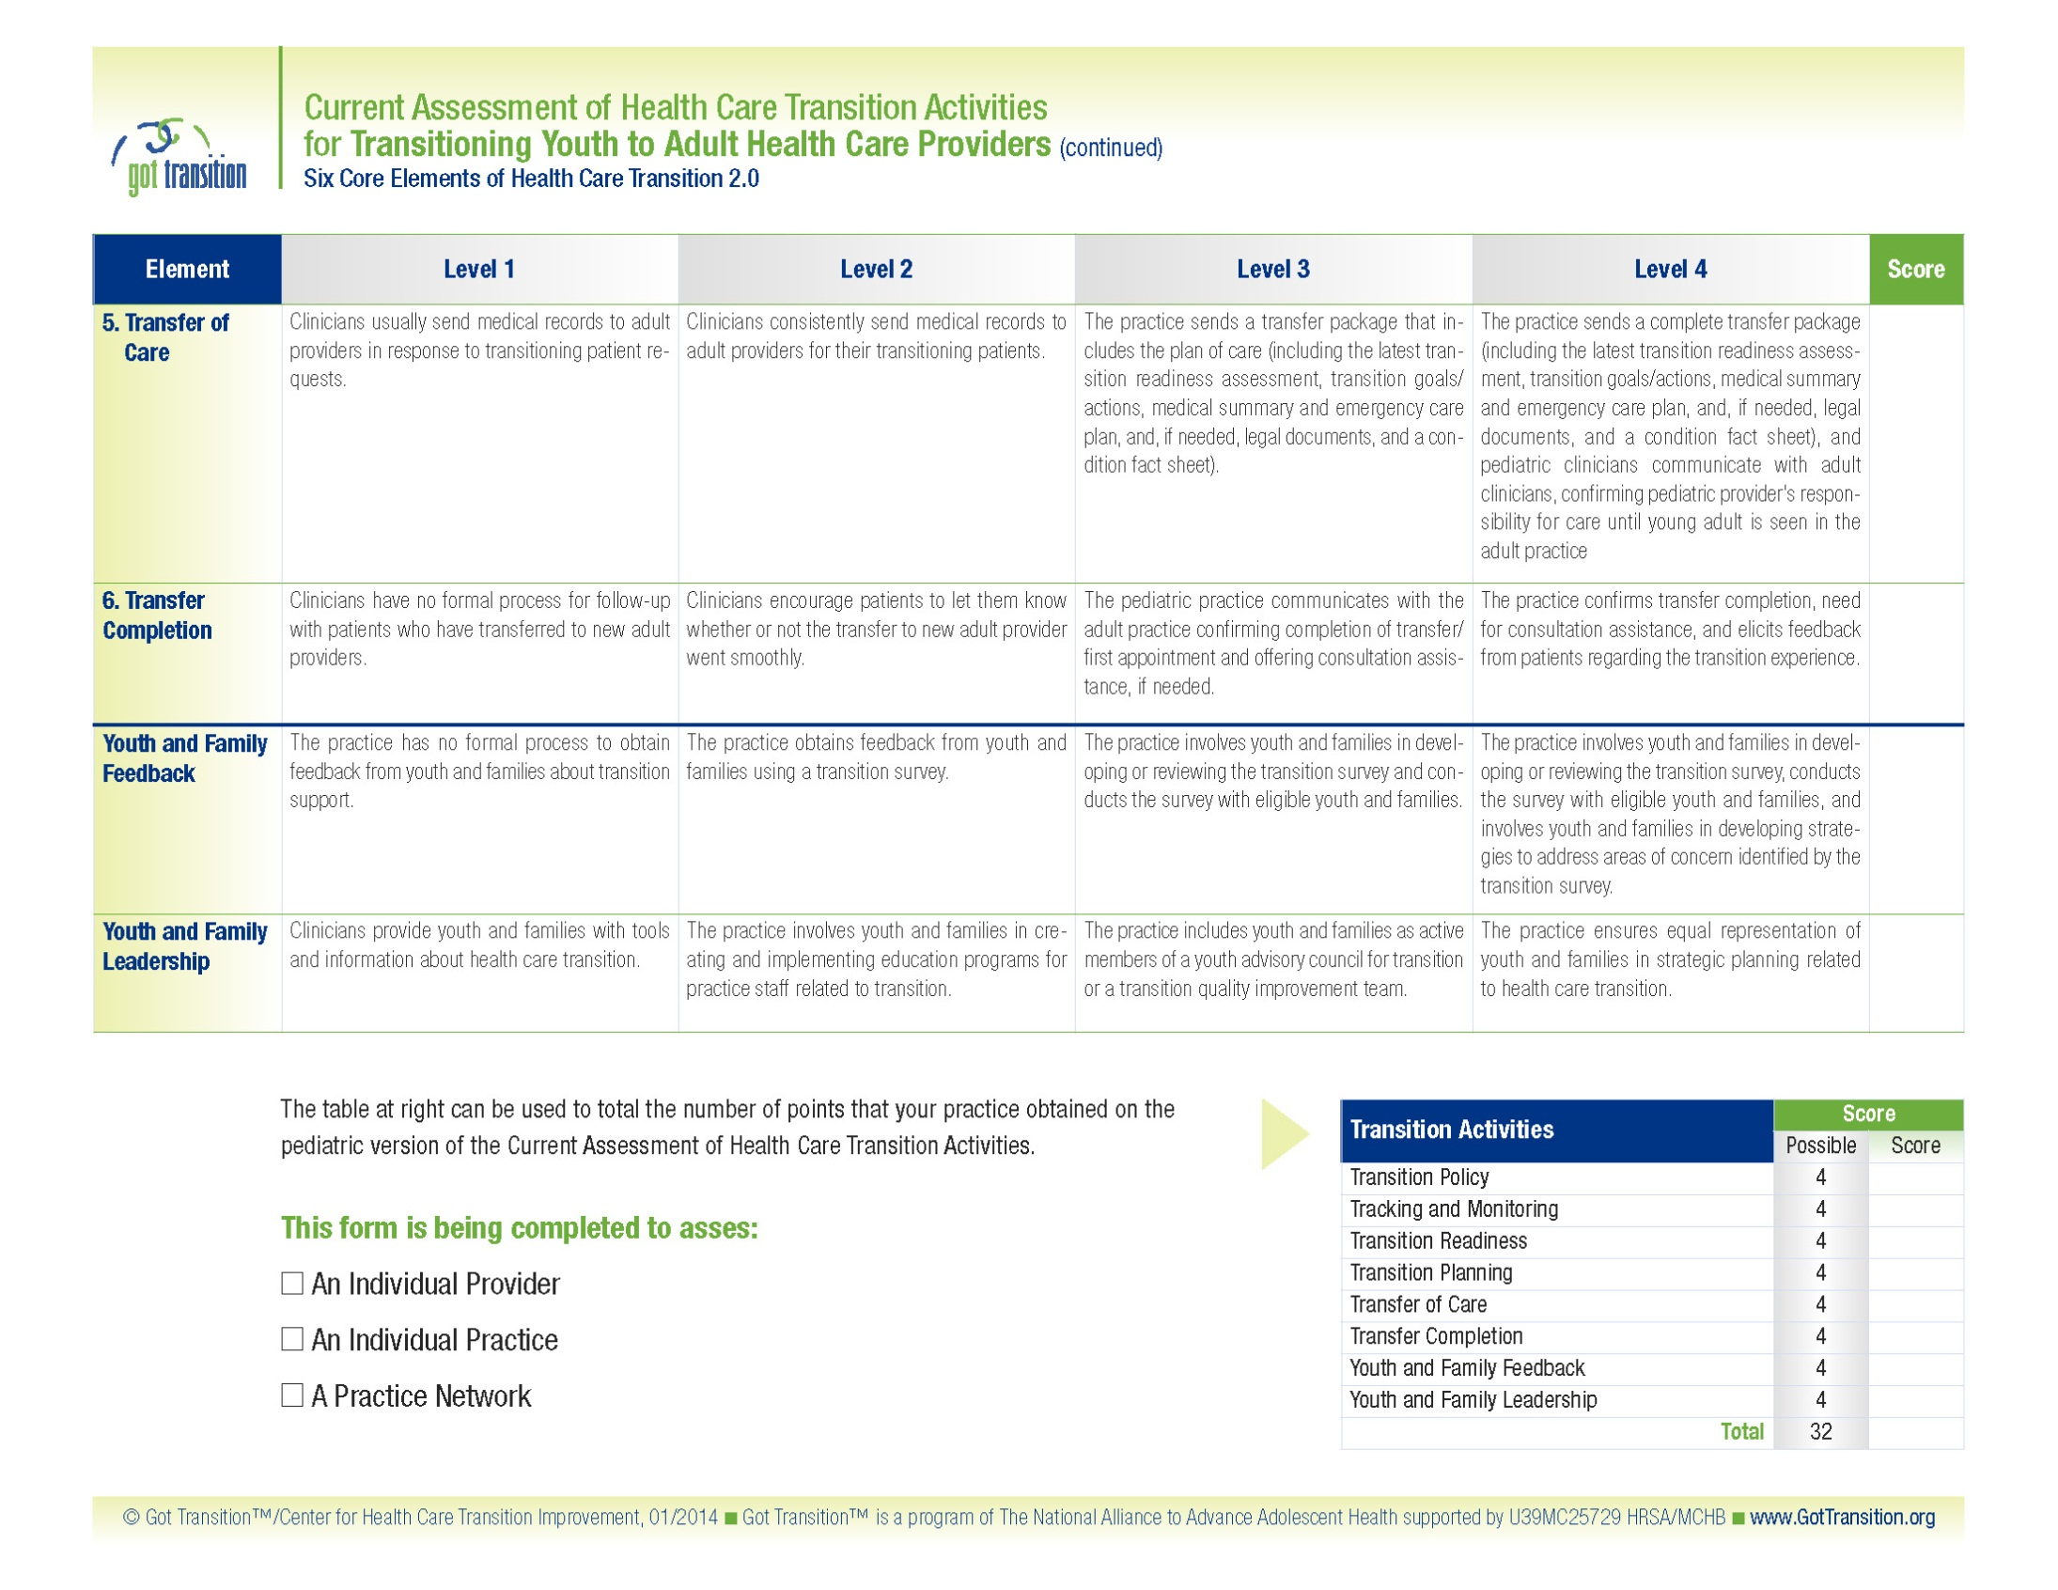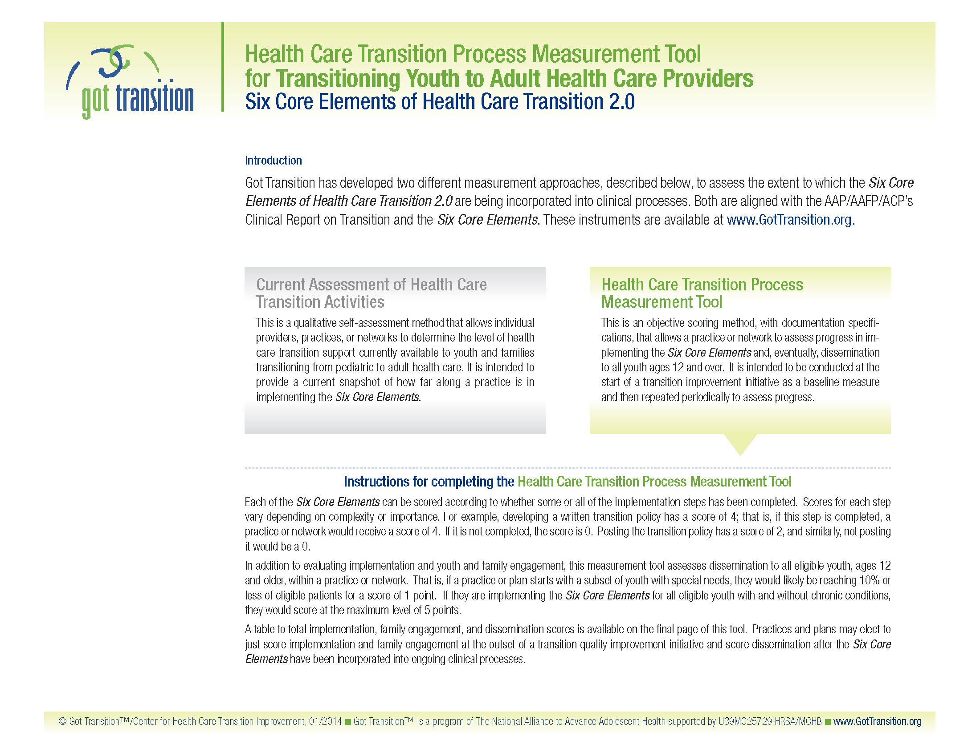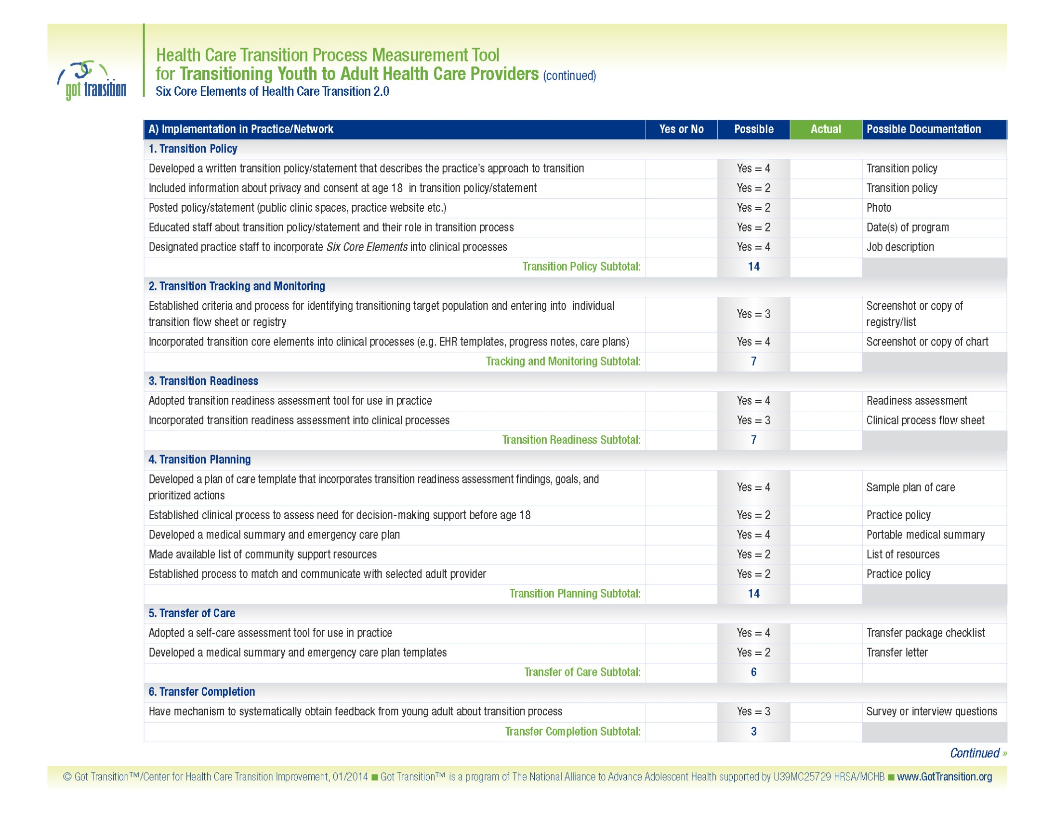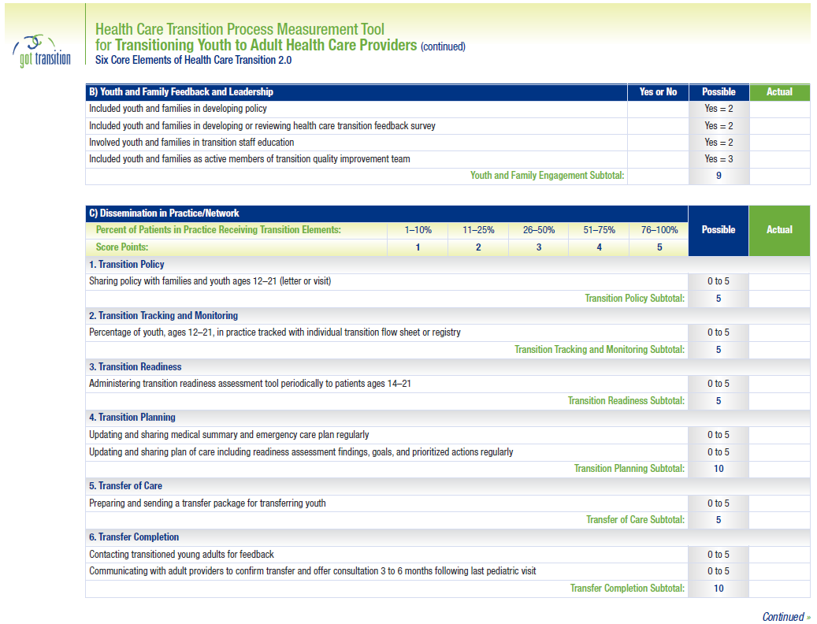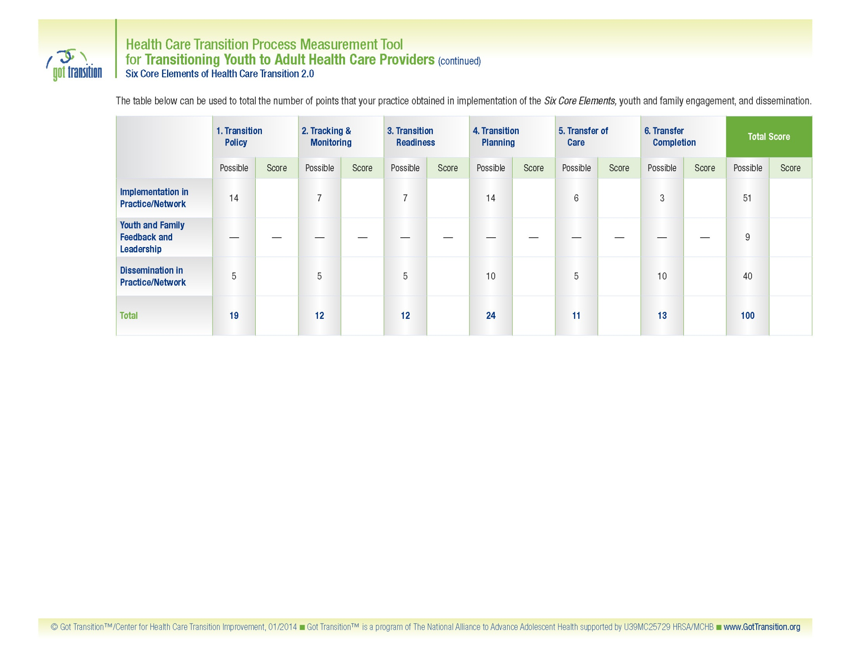

American Academy of Pediatrics, American Academy of Family Physicians, and American College of Physicians. Transitions Clinical Report Authoring Group. Supporting the health care transition from adolescence to adulthood in the medical home. Pediatrics. 2011: 128; 182.
Additional information can be found at: http://www.hhs.gov/ocr/civilrights/resources/specialtopics/lep/index.html and at: http://www.health.gov/communication/literacy/
Additional information can be found at www.thinkculturalhealth.hhs.gov
To access all three transition packages, see www.GotTransition.org.
White, PH, McManus MA, McAlister JW, Cooley WC. A primary care quality improvement approach to health care transition. Pediatric Annals. 2012: 41; 5.
Taylor MJ, McNicholas C, Nicolay C, Darzi A, Bell D, Reed JE. Systematic review of the application of the plan-do-study-act method to improve quality in healthcare. BMJ Quality and Safety. 2013:0;1.

